# Site Search

***Note:*** *this exercise uses PlasmoDB.org as an example database, but the same functionality is available on all VEuPathDB resources.*

**Learning objectives:**

* Search by keywords or identifiers
* Filter site search results by categories and fields
* Export results to a search strategy
* Find a specific gene using its ID in site search
* Navigate to and from the site search result
* Explore searches using wild cards (*)

The site search is located in the header of any VEuPathDB site and is available from every page. The site search queries the databases for your term or ID and returns a list of pages and documents that contain your query term.

1. **Search for a keyword**. Enter the word *kinase* in the site search window (arrow in the image below). Then click enter on your keyboard or click on the search icon (square in the image below).

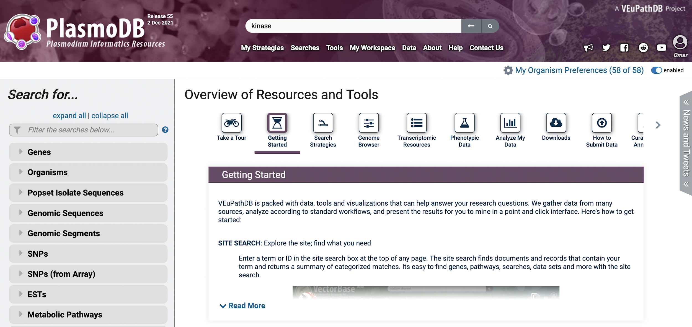

1. **Site Search result format**: The site search returns a categorized list of pages and documents that contain your term. Site search results are summarized on the left with a details panel on the right. Changing the panel on the left will populate the details panel with that result. What is the total number of results with the word kinase? Are all the results genes?

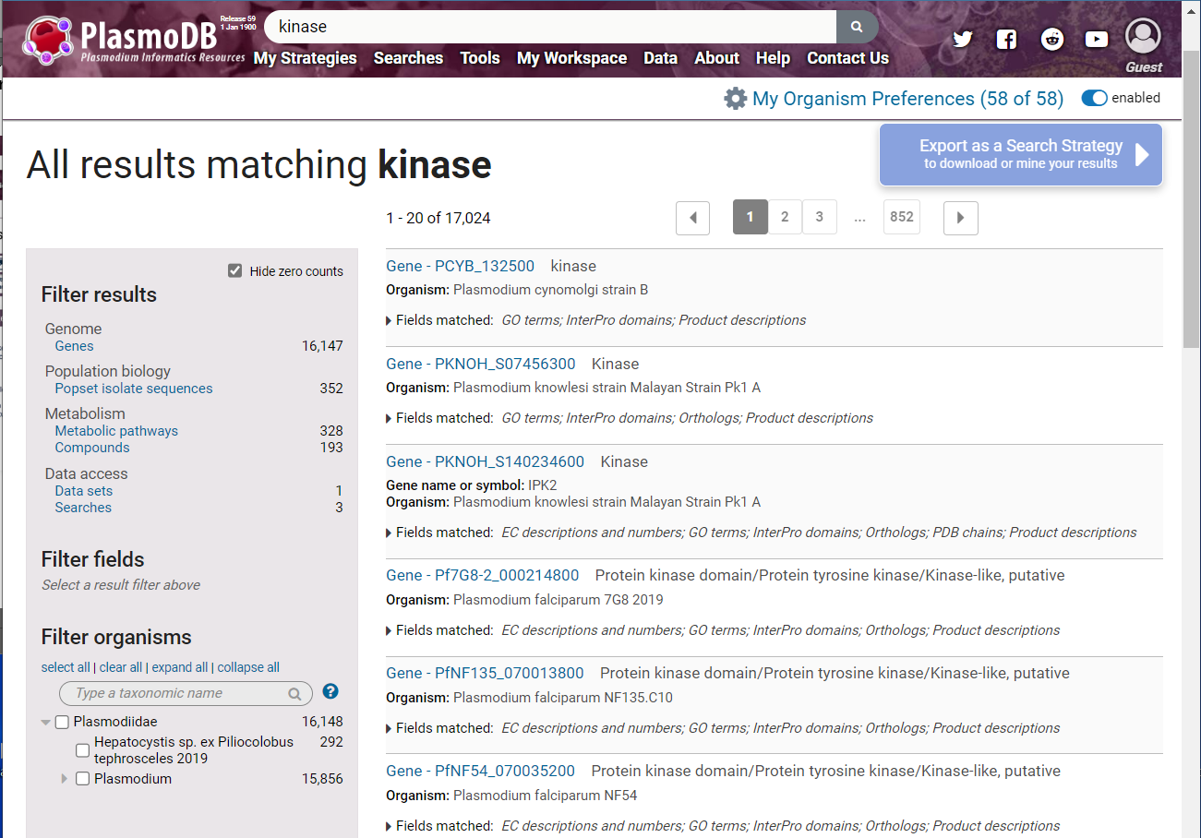

Results are summarized by category

Details panel with information about each item returned

1. **Filter the site search result by category:** How many of the genes included the word kinase in their product descriptions?

Filter the results so that you only view gene results (hint: click on the word *genes* in the *Filter results* section; arrow in image above) and the Filter Fields section expands to reveal additional filtering options. Select the *Product descriptions* field and choose *Apply* (middle panel below). Once a filter is applied it can be removed by clicking on *Clear filter* (right panel below).

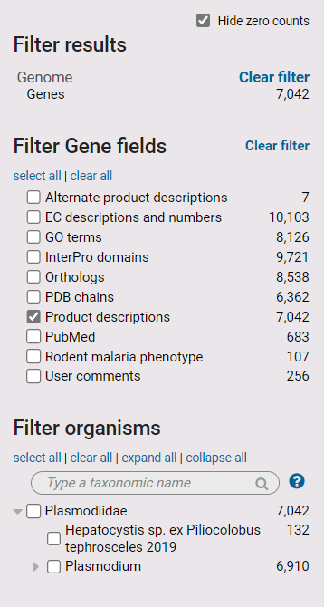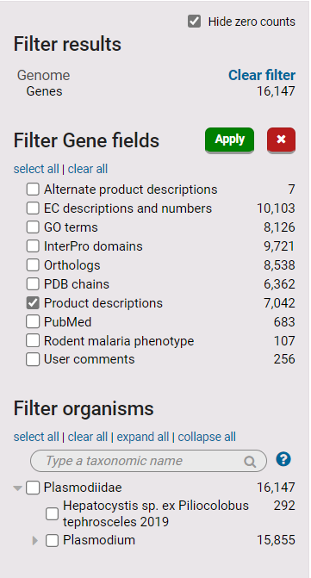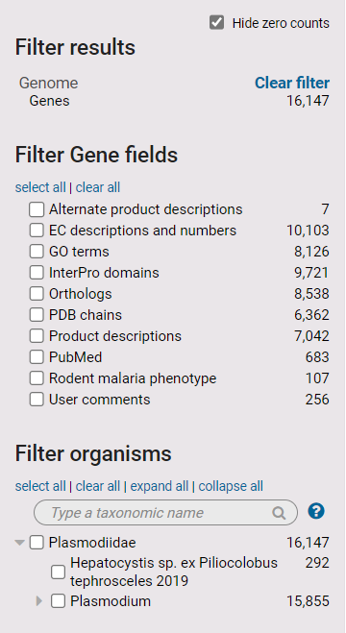

1. **Filter the site search result by field:** How many of the above genes are found in *Plasmodium falciparum* 3D7? Explore the *Filter organisms* section of the results filter and use the search filter to navigate the tree.

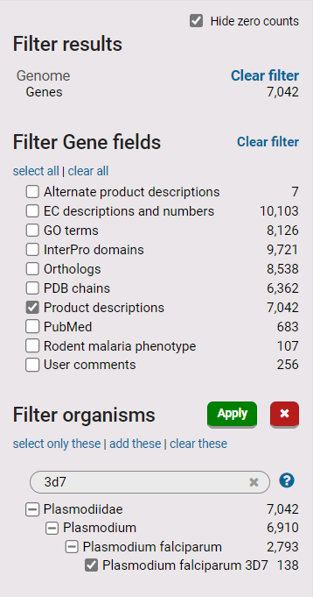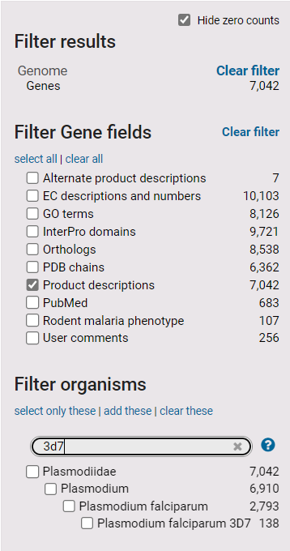

1. **Export the results to a search strategy**. Use the blue *Export as a search strategy* button at the top right-hand side of the results. Once exported you will be able to take advantage of over 100 specialized searches using the Add Step button. We will learn more about this in a future exercise.

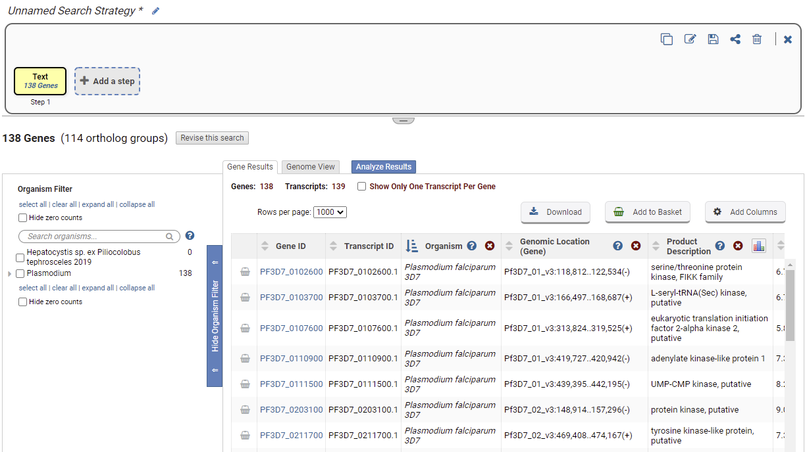

1. Return to the site search results page. You can achieve this in two ways: 1. Your previous results and filter settings were preserved and can be accessed by clicking on the ‘back to results’ arrow in the site search window. 2. Click on your browser’s back arrow.



1. **Clear all filters**. You can achieve this in two ways: 1. You can click on each of the clear filter options in the filter results panel (boxes below). 2. You can click on the *clear filters option* in the site search window, which serves to Clear All filters.

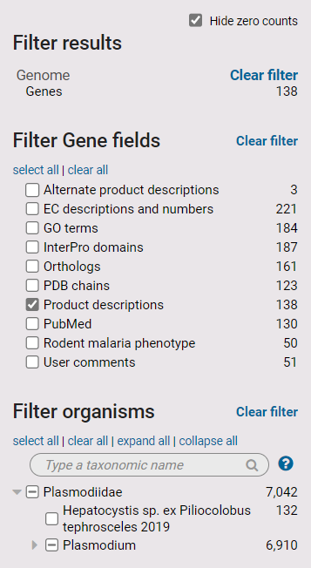

**1**

**2**

1. Click the *Hide zero counts* check box in the *Filter results* panel. What does this do?

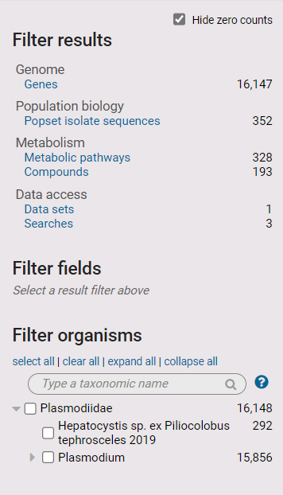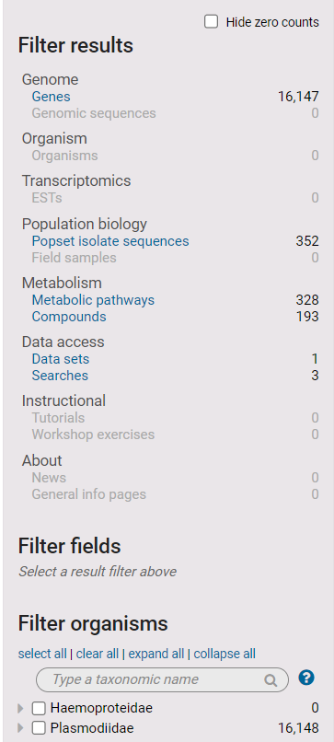

1. **Run a wild card search**. The wild card (denoted by an asterisk *) can be used alone to retrieve all site search results or combined with a word such as *\*kinase* to retrieve compound words ending with the word kinase like phosphofructokinase. As usual results can then be explored using the filters in the *Results filter* on the left side of the website.

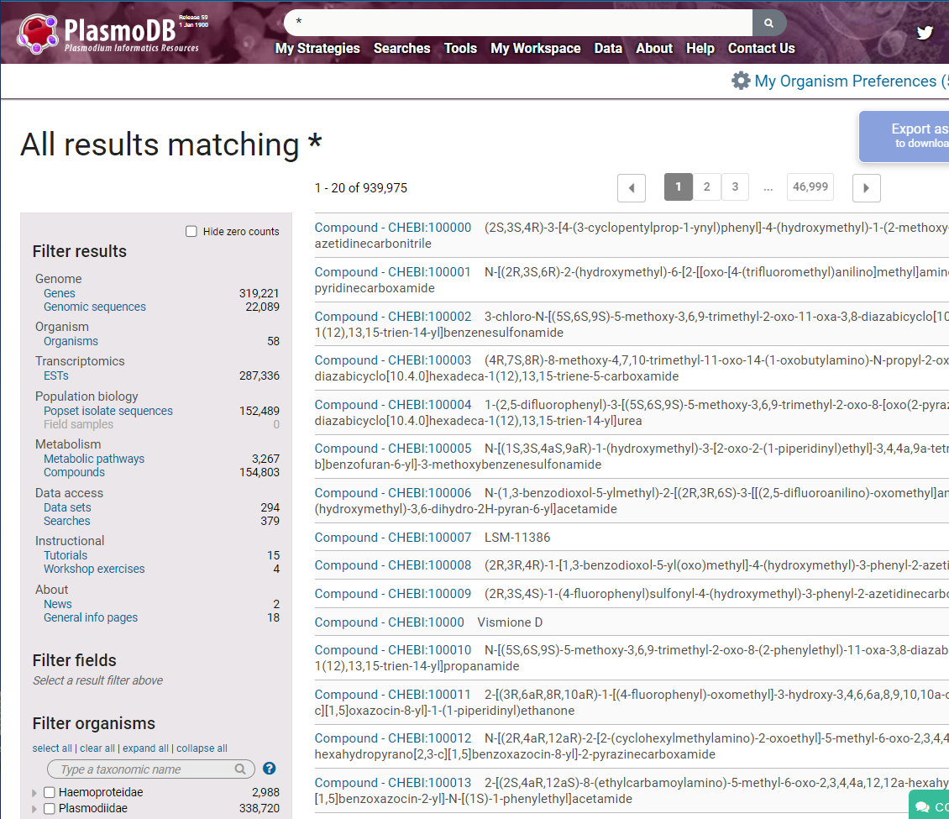

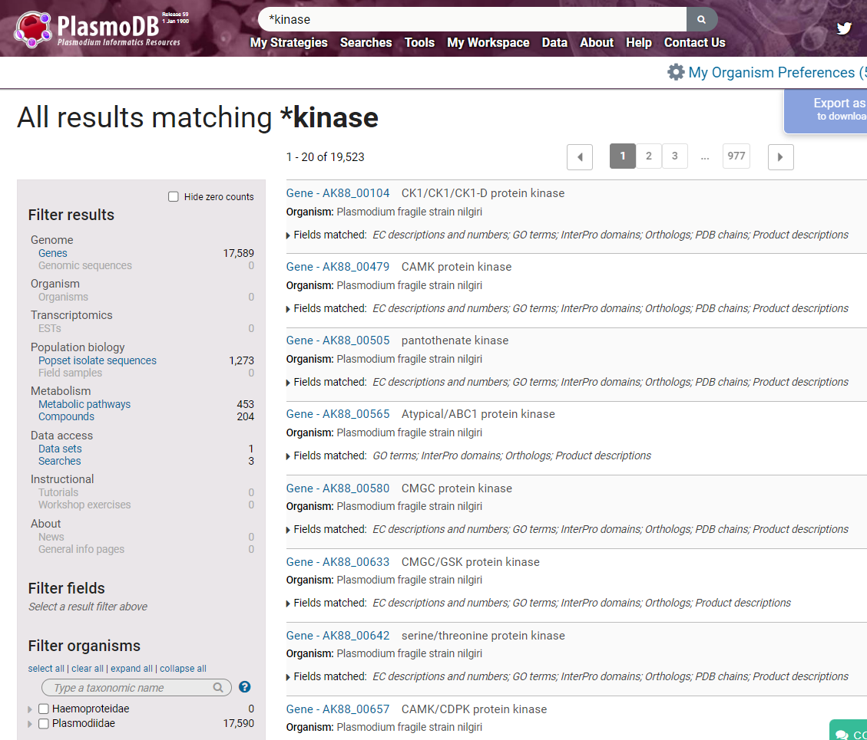

1. **Search for a specific gene ID**. Enter the gene ID in the site search window: *PF3D7_0310100*. When there is an exact match for an ID in the database, the site search offers a card in the details panel to draw attention to the direct link to the gene page.

